

**Lab Number: (9)**

**Subject: Database**

**Lab Objectives:**

This lab will give students practical experience on create a database.

Practice on connecting to database and insert data to table from php form.

**Lab Exercise:**

**Q1) Create a database library.sql**

* **Create a database table Book (BookNo, Title,Author,EditonYear)**
* **Insert the following 3 records:**

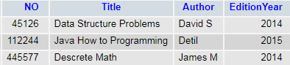

**Q2) addNewBook.php:**

**Design the following page to insert data to Book table after click**

**on Add Book button.**

